**First report**

On January 16, 2025, peppers that had undergone different treatments, to be described later, were taken to the Agricultural Engineering headquarters. These peppers were harvested on January 29, 2025 and were then left in storage for approximately two days (7°C). The peppers were divided into infection and control groups. In the control group, 125µL of sterilized distilled water was introduced using 200µL gel loading tips (manually cut at the tip), while in the other group, the same volume of a conidial suspension of the fungus *Alternaria alternata* with a concentration of 10⁷ spores/mL was introduced. The liquid was introduced through the blossom end of the fruit. The fruits were stored at 20°C for 16 days before being opened for Raman analysis.

For the laser analysis, four groups were formed, with the aim of analyzing significant differences between the different samples. Each group was composed of five replicates of samples from the pepper pericarp. For this experiment, we analyzed the external part of the fruit, the cuticle.

Group 1: was formed by peppers from the control group, healthy and without any sign of infection. The laser exposure time was approximately 8 seconds, each repetition resulted from an average of 10 measurements.

Group 2: consisted of infected peppers, showing signs of infection in the placenta and seeds. The analyzed tissue was taken from an area distant from the infection, closer to the blossom end. The laser exposure time was approximately 8 seconds, and each repetition resulted from an average of 10 measurements.

Group 3: consisted of infected peppers, showing signs of infection in the placenta, seeds and on the pericarp. The analyzed tissue was taken from an area close to the infection, near the placenta. The laser exposure time was approximately 8 seconds, and each repetition resulted from an average of 10 measurements.

Group 4: consisted of infected peppers, showing signs of infection in the placenta, seeds and on the pericarp. The studied tissue was located right above the infected internal tissue, but without visible signs of infection in the cuticle. The laser exposure time was approximately 8 seconds, and each repetition resulted from an average of 10 measurements.

After the experiments were performed, the measurements were normalized to reduce the risk of results being compromised by different exposure times or focus levels used. Five graphs were generated to present the different groups with their respective five repetitions, along with a comparative graph that represents each group as the average of its repetitions.

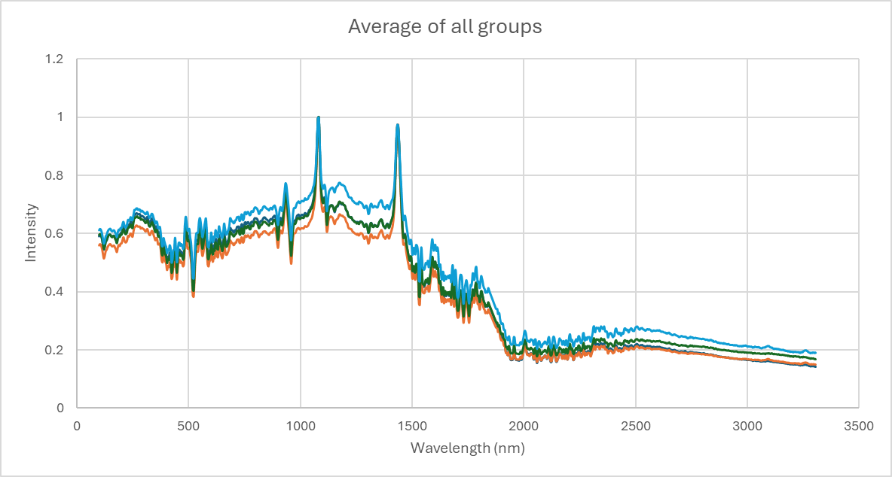

Apparently, there is greater laser absorption, particularly between wavelengths of ~900 nm and ~1400 nm, in Groups 4 and 3. These groups represent samples from fruits with internal infection. It is necessary though to verify the significance of the results.